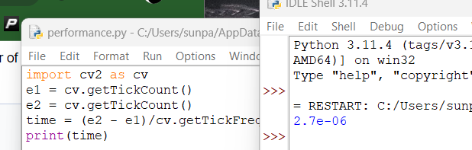

Measuring run time

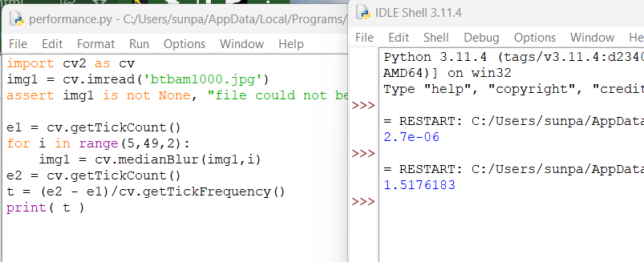

Median filtering with increasing kernel size

Performance testing

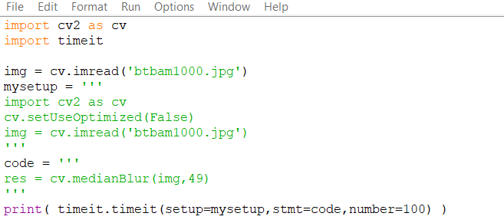

code

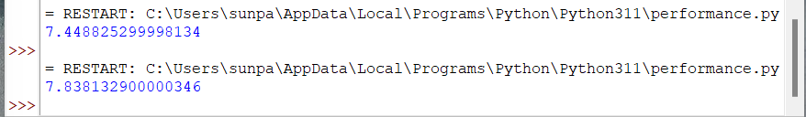

First time is optimized 100 runs, second is unoptimized 100 runs, not significantly slower?